**User Story: Web Admin can add advisor account. (Iteration 1)**

Task: Write user documentation for adding coop advisor account.

Web admin is the one who add coop advisor account in the system and this is one of the primary function of the web admin in the system. As a web admin you need some basic information of each coop advisors such as advisor first name, last name, user ID, cell no, email, advisor area, password. Among the information advisor phone and cell no are optional rest of all are mandatory. Further, user id is numeric nine digits field, and password must be 4 to 8 digits long with at least 1 numeric entry. The functionality to add advisor in located in web admin home page (see figure 7). After you entered all mandatory info regarding advisor and select add advisor account button the system will create the advisor account in the system. Web admin also have additional functionality to manage all user accounts in the system which will be discussed later.

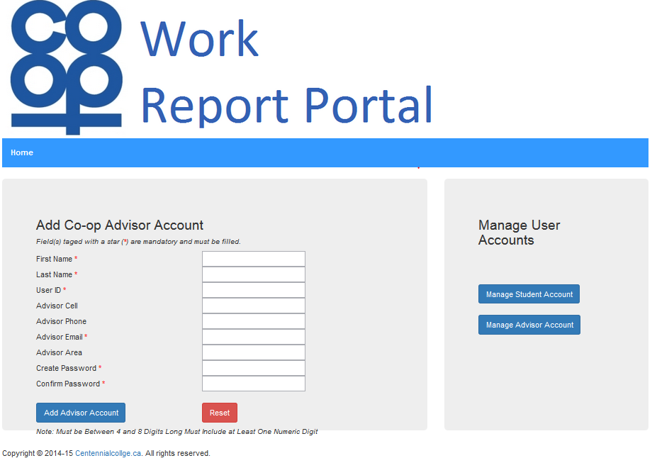

*Figure 7 CoopReporting application: student work report submission*